Uriel Valencia

Stanford Nano Facilities

30 August 2023

**Vapor Phase Decomposition (VPD) Machine - Wafer & Cuvette Holder Base, Wafer Holders, and Cuvette Holders**

**Wafer & Cuvette Holder Base (Original Design - 8/13/23):**

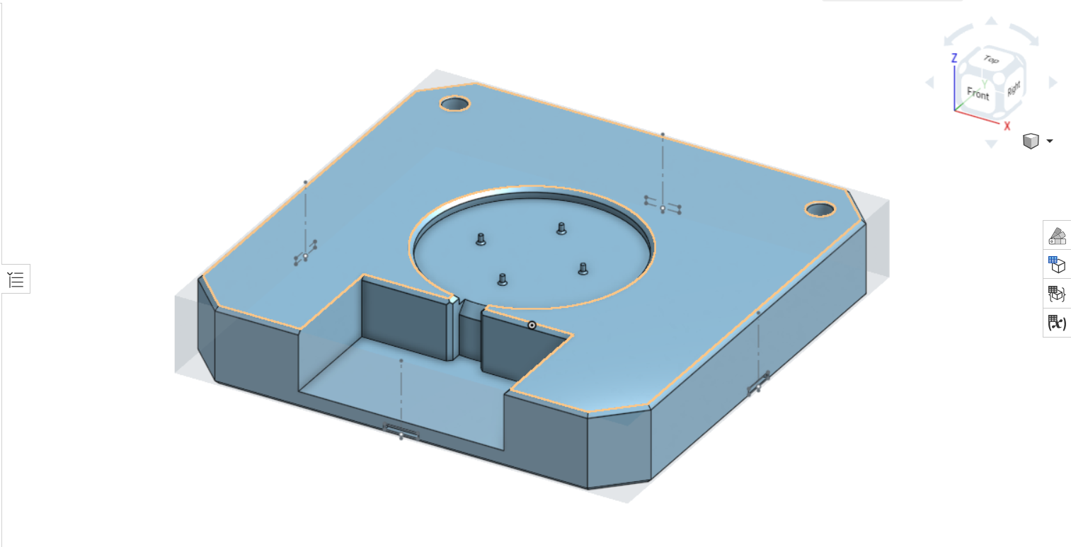

*Figure 1: Wafer & Cuvette Holder Base (Original Design)*

The original design for the Wafer & Cuvette Holder Base (to be referred to as “The Base”, from now on) was designed by taking measurements of a Cuvette, a 4” (100 mm) Silicon Wafer, Binder Clips, the bed of an Ender 3 3D Printer, and Wafer Tweezers. Rulers, as well as Calipers, were used to take measurements (in mm).

* The dimensions of The Base were determined by taking the height of a cuvette (40 mm), as well as the length and width of the Ender 3 3D Printer Bed (235 mm x 235 mm). The height of The Base was 38.6 mm, and the length and width were 225 mm x 225 mm after making some adjustments.
* Slots for binder clips were positioned on the Front, Left, Back, and Right sides of The Base. The dimensions for the slots were determined by taking measurements of the binder clips. The dimensions of the binder clip slots were 3 mm high x 16.5 mm wide x 3 mm wide.
* Two cuvette slots were made on the Top face of The Base. The height and diameter of the cuvette slots were determined by taking measurements of a cuvette. The dimensions of the cuvette slots were 38.6 mm deep, with a diameter of 11.5 mm.
* A slot for 4” silicon wafers was made on the Top face of The Base. The diameter of the wafer slot was erroneously determined by assuming that a 4” silicon wafer had a diameter of 101.6 mm. The diameter of the wafer slot was 102.1 mm. Four pegs were included on the bottom of the wafer slot to prevent either side of a silicon wafer from coming in full contact with The Base. The depth of the wafer slot was 5 mm, and the height of the pegs were 4 mm so that, when the silicon wafer was resting on the pegs, the surface of the silicon wafer would be flush with the Top face of The Base.
* A big cut out was placed on the Front face of The Base so that a hand could move with ease when handing wafer tweezers. There is another slot between the big cut out and the wafer slot. The width of the tweezer slot was determined by measuring the width of a wafer tweezer, 12.7 mm wide. The width of the tweezer slot was 14 mm wide. The tweezer slot was made so that any user could place or remove a 4” silicon wafer on the wafer slot.

The following sections will mention what did not work in the original design, the following versions, and what was done to improve on what did not work.

**Wafer & Cuvette Holder Base (Original Design - V2 - 8/17/23)**

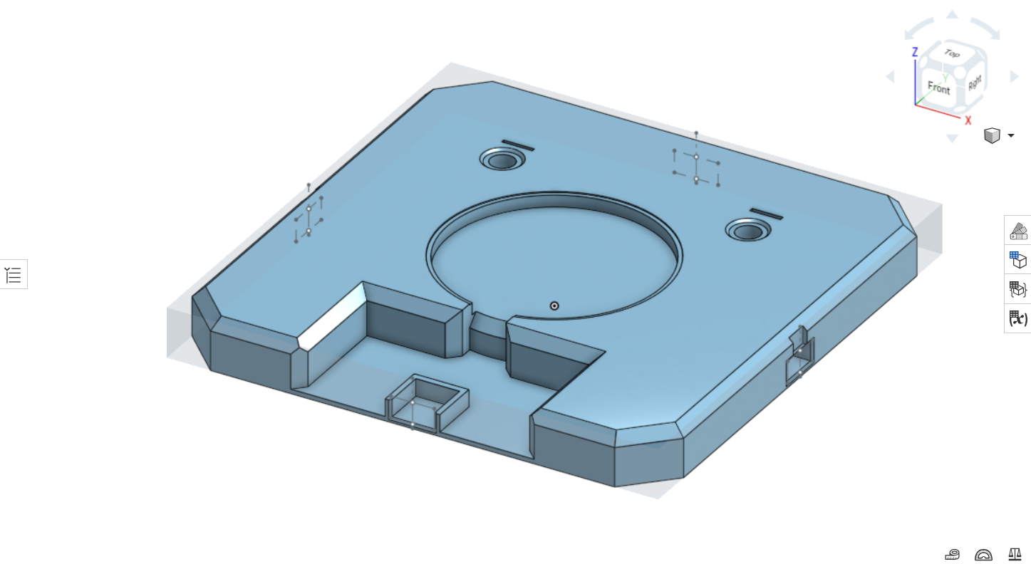

*Figure 2: Wafer & Cuvette Holder Base (Version 2)*

* The original design of The Base was too bulky. The length and width dimensions remained the same, but the height was reduced to 23 mm.
* The binder clip slots were not functional; the binder clips could not go into the slot. To fix the problem, the dimensions of the binder clips slots were changed to: 10 mm high x 20 mm wide x 20 mm long. This gave the binder clips enough clearance to go into the binder clip slots. An additional was made above the binder clip slots so that the handles of the binder clips could rest on them so the handles would not interfere with the bed of the Ender 3 3D printer when it moves in the y- direction.
* The two cuvette slots where the cuvettes would be placed in were too snug; force was needed to put in, and remove, the cuvettes from the circular slots. To fix this, the diameter was increased to 11 mm. The depth changed to 23 mm since the height of The Base was reduced to 23 mm. Additionally, there was an issue with repeatability; there was no way to prevent the cuvettes from moving in a circular motion while in the cuvette slots. To prevent the cuvettes from moving, slots for the caps of the cuvettes were made near the cuvette slots to hold the cuvettes in place. The dimensions of the cap slots were 1.6 mm long x 14 mm wide x 23 mm deep.
* The diameter of the wafer slot was too big. The diameter of the wafer slot was reduced to 101.86 mm. Also, the silicon wafer was not stable when placed on the pegs. Applying force to certain areas, like closer to the edge of the silicon wafer, would cause the silicon wafer to tilt. To fix this, the pegs were removed, and a ring that was 1mm lower than the wafer slot was used instead. The wafer ring was 98 mm in diameter.
* The wafer tweezer slot was too narrow; there was no room for the wafer tweezers to move sideways when placing or removing a silicon wafer. To fix this, the width of the wafer tweezer slot was increased to 20 mm.

**Wafer & Cuvette Holder Base (Original Design - V3 - 8/18/23)**

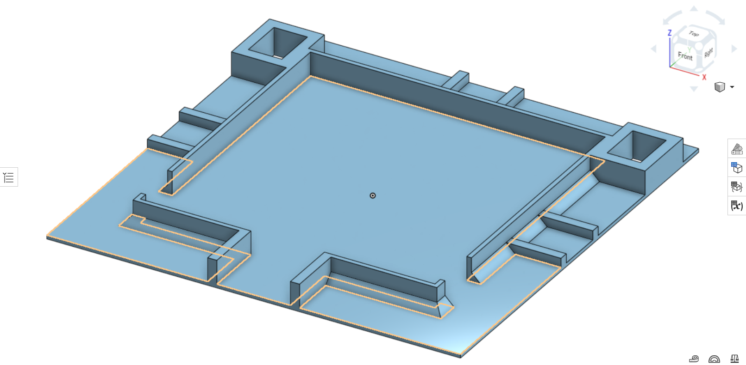

*Figure 3: Wafer & Cuvette Holder Base (Version 3)*

In this version of The Base, the wafer slot holder was removed. Since silicon wafers come in different diameters, 51 mm, 100 mm, and 150 mm, it was decided that a larger, rectangular slot, should be made so that three different wafer holders could be made, and therefore interchangeable. Also, the cuvette slots were removed, as well as the cap slots, in favor of cuvette holder slots, where cuvette holders could be inserted into the slots.

* The length and base of The Base remained the same. However, the height was reduced to 15 mm, but this was not applied to the entirety of The Base. The walls of the new wafer holder slots, as well as the cuvette holder slots, were elevated 13 mm high from the base, which was elevated 2 mm high.
* The width of the binder clip slots was increased to 25 mm. The length was increased to 29.85 mm so that the walls on either side of the binder clip slots would act as support for the walls of the wafer holder slot. The walls on either side of the binder clip slots were 5 mm wide, with a height of 5 mm.
* The cuvette slots, and cap slots, were removed and replaced with cuvette holder slots (cuvette holder slots will be talked about later). The external perimeter dimensions of the cuvette holder slots were 35.85 mm long, 29.85 mm wide, and 13 mm high. The internal perimeter dimensions of the cuvette holder slot were 24.2 mm wide, 18.2 mm wide, and 15 mm deep.
* The wafer slot was replaced with the wafer holder slot. The external perimeter dimensions of the wafer holder slot were 165.3 mm long and wide, with a height of 13 mm. The internal perimeter dimensions of the wafer holder slot were 160.3 mm long and wide, with a depth of 15 mm. Wafer holders will be talked about later.
* The big cut out from Version 1, and the wafer tweezer slot, became one. The new wafer tweezer slot was 40 mm wide and 29.85 mm long. The walls next to the wafer tweezer slot were 5 mm wide, 29.85 mm long, and 13 mm high.
* Cut outs were made on the Left and Right faces of the wafer holder slot. The cut outs were 8 mm long, 25 mm wide, and 13 mm high.

**Wafer & Cuvette Holder Base (Final Version - 8/29/23)**

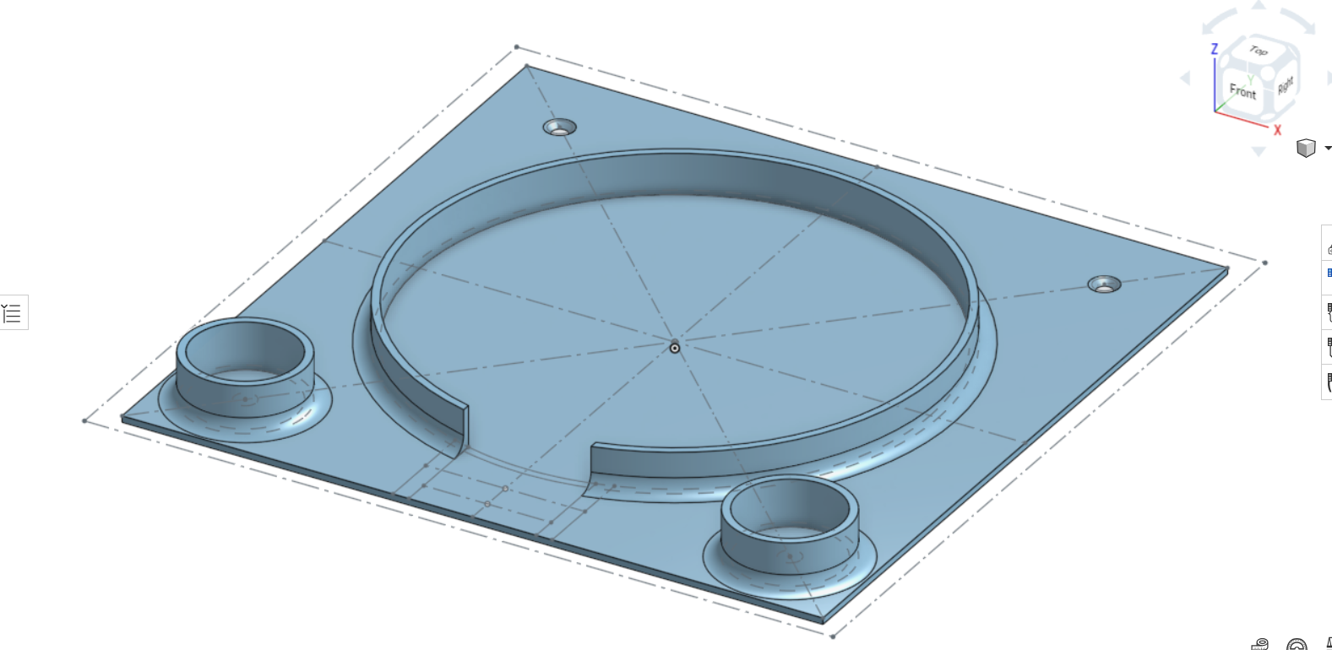

*Figure 4: Wafer & Cuvette Holder Base (Final Version)*

For the Final Version, the binder clip slots from previous iterations were removed, and instead replaced with holes so that The Base would be bolted on to the bed of the Ender 3 3D Printer. Also, the wafer holder slot, and the cuvette holder slots, were redesigned to be round, as opposed to square or rectangular. This design is better for when The Base gets manufactured.

* The length and width of The Base was reduced to 220 mm x 220 mm. This was done so that the length and width of The Base was within the effective printing area of the Ender 3D printer. Overall height of The base is 15 mm. The base is 2mm high, and the height of the wafer and cuvette holder slots are 13mm high.
* The binder clip slots were removed in favor of counter sink, standard M4 holes. The advantage to the counter sink holes is that the screws of the levels (on the bottom of the Ender 3 3D Printer bed) can be used to fasten the The Base onto the Ender 3D Printer bed.
* The previous cuvette holder slots were redesigned to be round. Easier to manufacture. The cuvette holder slots were moved from the back of the Top face to the front. Also, the two cuvette holder slots are located where two of the counter sink holes are located; the counter sink holes will not interfere with the cuvette holders.
* The wafer holder slot was redesigned to be round; easier to manufacture. The cut outs to remove the interchangeable wafer holders were removed. Instead, the cut outs were made on the bottom of the wafer holder, which can be accessed from the wafer tweezer slot.
* The walls next to the wafer tweezer slot area were removed, as they were unnecessary at this point. The width of the wafer tweezer slot remained the same.

**Rectangular Cuvette Holder (Original Version - ~ 8/15/23)**

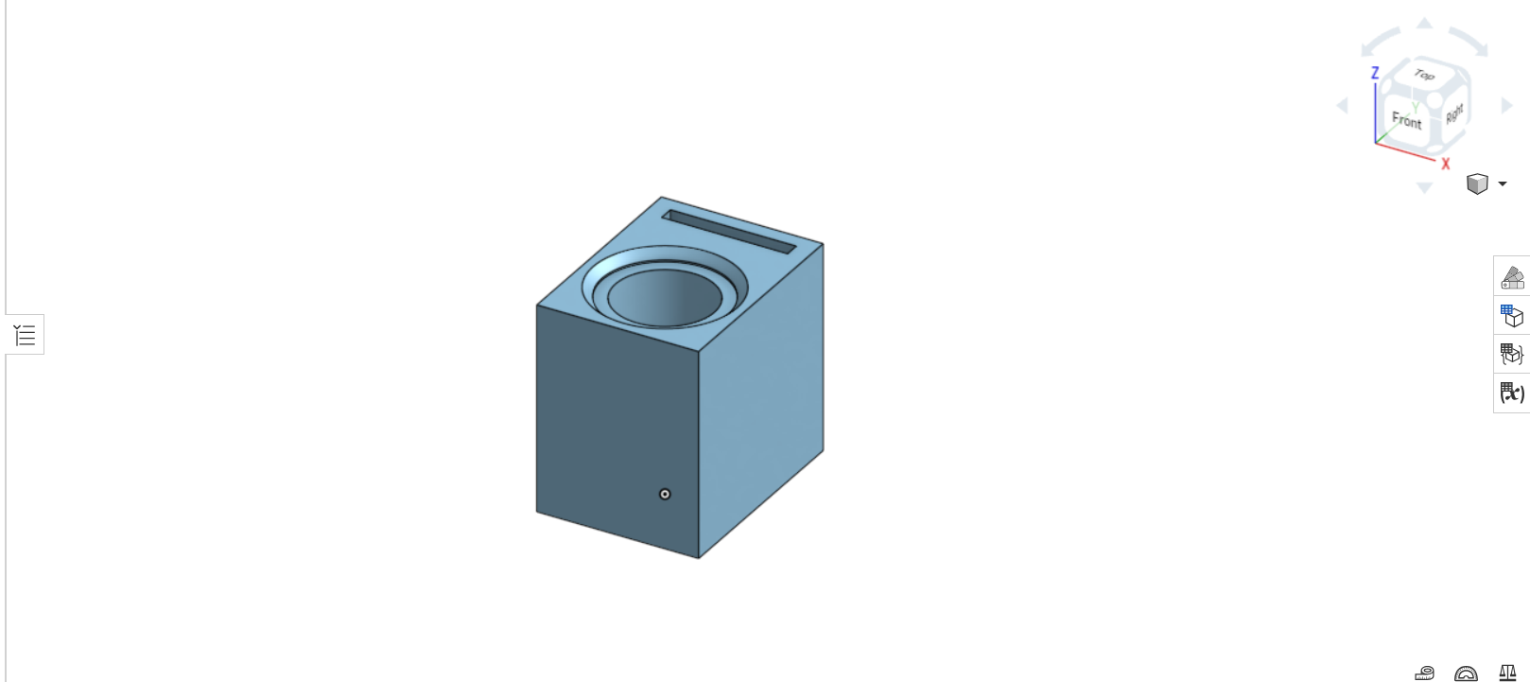

*Figure 5: Rectangular Cuvette Holder (Original Design)*

This Rectangular Cuvette Holder (to be referred as “The Cuvette Holder” from now on) was made during V3 of The Base was being designed.

* The cuvette Holder is 24 mm long x 18 mm wide, with a height of 23 mm. The height of The Cuvette Holder was intentionally higher than the cuvette holder slot on The Base so that The Cuvette Holder could be easily placed and removed.
* The diameter of the slot where the cuvette goes in is 11 mm, and it is 23 mm deep (from Top face to the Bottom face. The cap slot is 1.7 mm long and 14 mm wide, with a depth of 23 mm.
* The lip of the cuvette does not rest on the Top face of The Cuvette Holder. The Cuvette Holder is intentionally shorter than the cuvette so that the cuvette can be easily placed and removed from the cuvette slot.

**Round Cuvette Holder (Final Version - 8/29/23)**

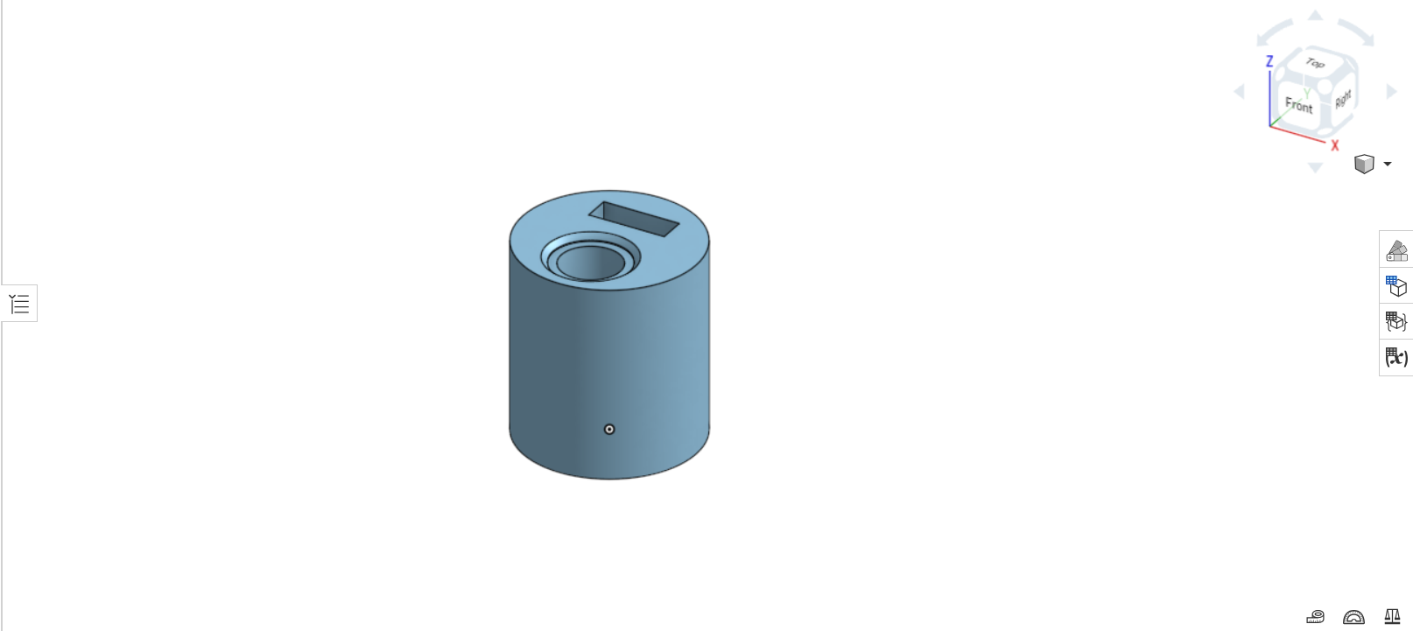

*Figure 6: Round Cuvette Holder (Final Version)*

The (Round) Cuvette Holder was made when the Final Version of The Base was being designed.

* The Cuvette Holder was redesigned to be round so it would fit in the circular cuvette holder slots in the Final Version of The Base. The diameter of The Cuvette Holder is 32 mm, and its height was increased to 35 mm so that the cuvette would have less room to move around.
* The diameter of the cuvette slot was reduced to 10.9 mm so that the cuvette would move around less. The depth of both the cuvette slot, and the cap slot, was increased to 35 mm. The length of the cap slot was increased to 4.9 mm so that more of the cap would fit in the slot.

**Wafer Holder (Original Version - 8/21/23)**

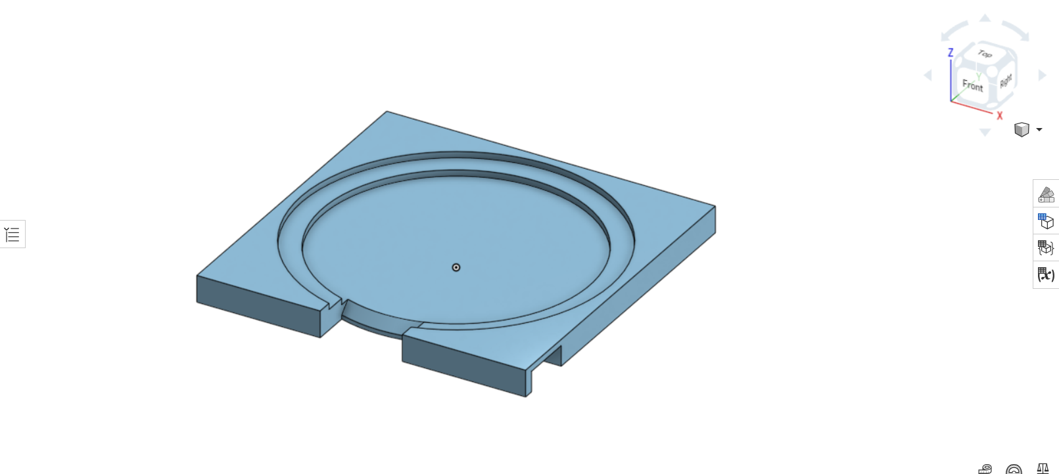

*Figure 7: 6” Wafer Holder (Original Version)*

The Wafer Holders (of sizes 51 mm, 100 mm, and 150 mm) were designed when V3 of The Base was being designed. The idea was to create three separate wafer holders, for each size of silicon wafer, so that they could be interchangeable with V3 of The Base.

* The dimensions of the wafer holder (for all three sizes) were 160 mm long x 160 mm wide, with a height of 13 mm.
* The difference between the three wafer holders are the diameters of the wafer slots, as well as the wafer rings the silicon wafers rest on. The 6” Wafer Holder (Figure 7) has a wafer slot diameter of 150.6 mm, and a wafer ring diameter of 130 mm. For the 4” Wafer Holder, the wafer slot diameter was 100.6 mm, with a wafer ring diameter of 80 mm. For the 2” Wafer Holder, the wafer slot diameter was 51.6 mm,and the wafer ring diameter was 30 mm.
* The wafer tweezer slot remained the same; 40 mm wide.
* Slots to remove and place the wafer holder from The Base were placed on the Left and Right faces of the wafer holders. The slots were 20 mm long by 25 mm wide, with a height of 10 mm.

**Wafer Holder (Final version - 8/29/23)**

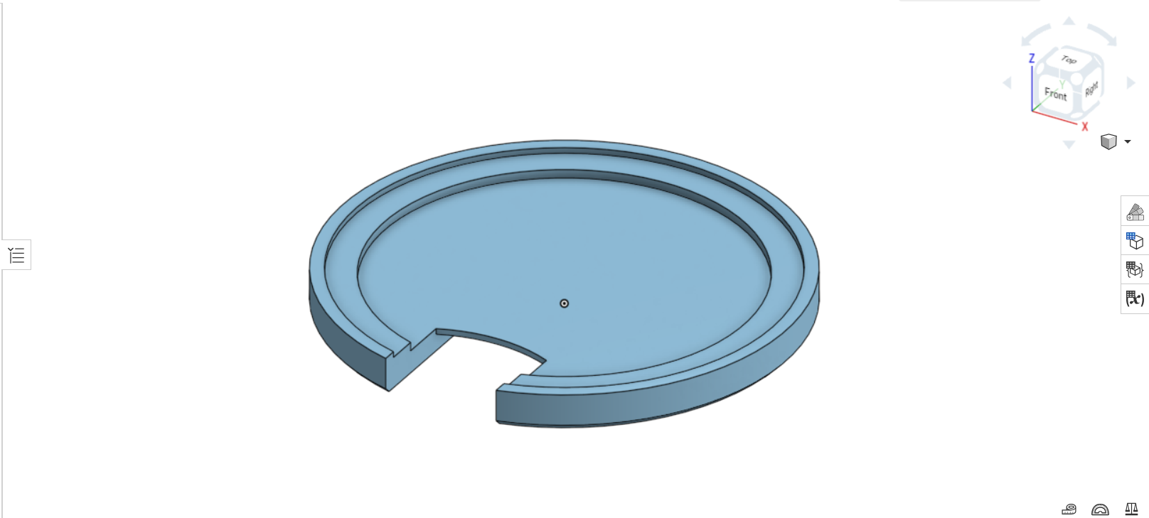

*Figure 8: 6” Wafer Holder (Final Version)*

The Final version of the wafer holders (51 mm, 100 mm, and 150 mm) were redesigned so that they would fit the Final Version of The Base.

* The wafer holders were redesigned to be circular so that they would fit the circular wafer slots of the Final Version of The Base. All three wafer holders had a diameter of 160 mm. Diameters for the wafer slots, as well as the wafer rings, remained the same.
* The width of the wafer tweezer slot remained unchanged.
* The slots to place and remove the wafer holders from The Base were removed from the, and instead a slot was created under the wafer tweezer slot. For all three wafer holders, the dimensions of the slot to place and remove the wafer holder are 25 mm long x 40 mm wide, with a height of 6 mm.